DBMS::A ****Database Management System****is a collection of programs that enable users to access, manipulate, and display the data stored within databases. eg. RDBMS.

RDBMS::Relational databases are data bases that are stored in a tabular form and represent data, that is related to one another eg. MySQL(Oracle server),Sql Server(Microsoft SQL)

SQL::Stands for Structures Query Language, is a language for interacting with the data stored in relational databases. Each RDBMS has its own SQL language.-

PL/SQL::Oracle’s procedural extension of SQL which offers features as data encapsulation, overloading, collections types. I is proprietary by Oracle.

SQL Lite:: 3rd party, open source and in-process database engine by Microsoft.

***The only interface available between end users and an RDBMS is SQL.***

**Each relational database comes up with their own SQL language which contain certain features of SQL and they may implement certain features in their own way. **

MODULE 1:

1) Tables Database for developers:

TYPES OF TABLES available for oracle database:

*By default tables are HEAP organized. This means articles will store new rows where ever it can find empty space.

*Structured tables: Everything is organized in a structured tabular manner. But this can increase the workload of the developers trying to store information in a tabular form. But this makes it easier to find things sorted together.

*External Tables: Are used to access non database files. Used as a staging area before you load your data.

*Temporary Tables: Stores data private to each session. No one can access or see the information you add.

*Partition Tables: Splits your table into smaller tables.Rows are split in partition according to the partition key.

*Table Cluster:Tables stores related information together.

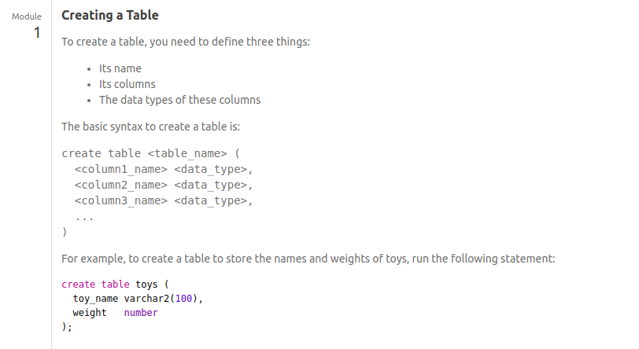

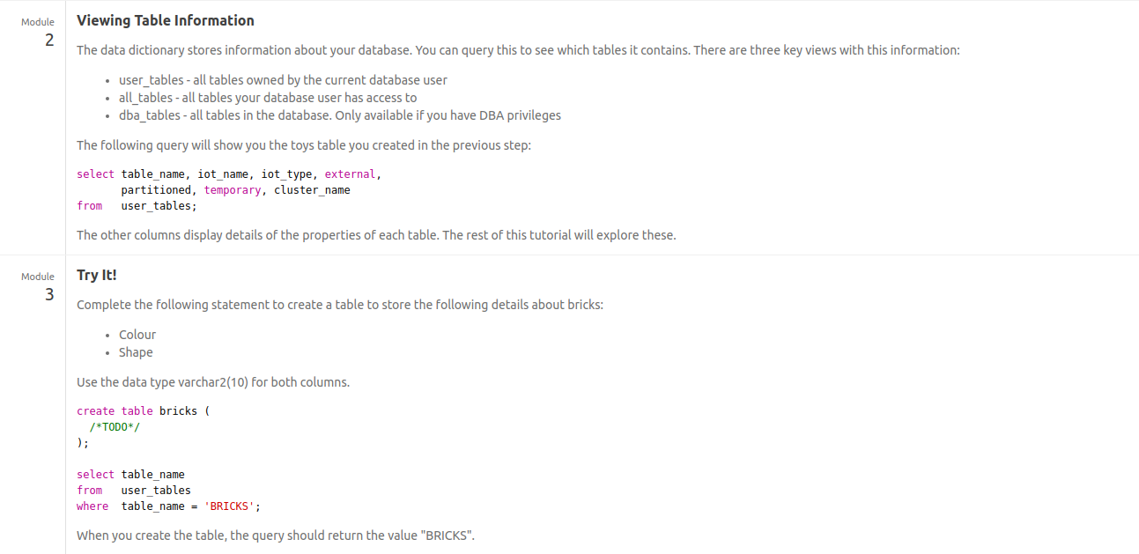

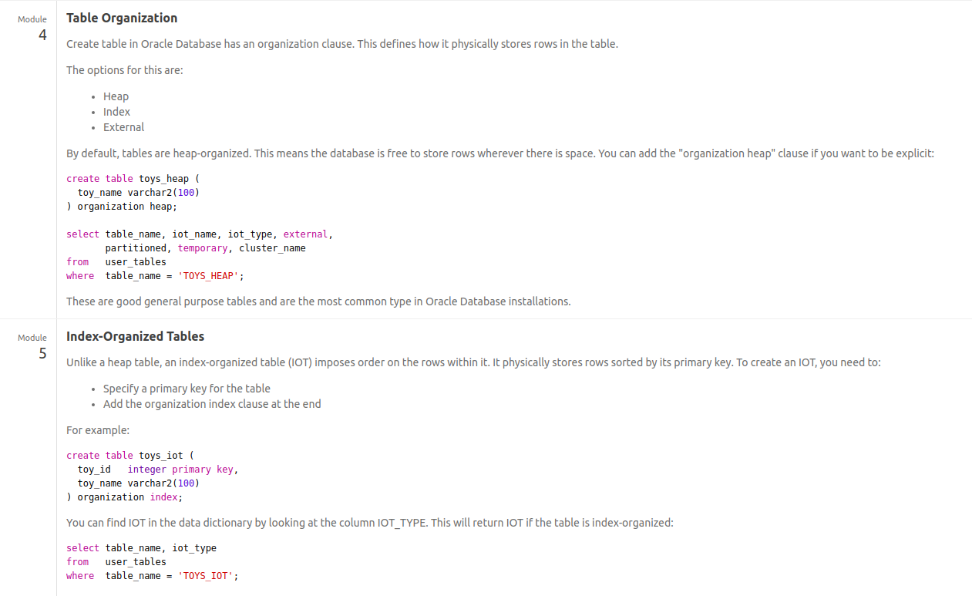

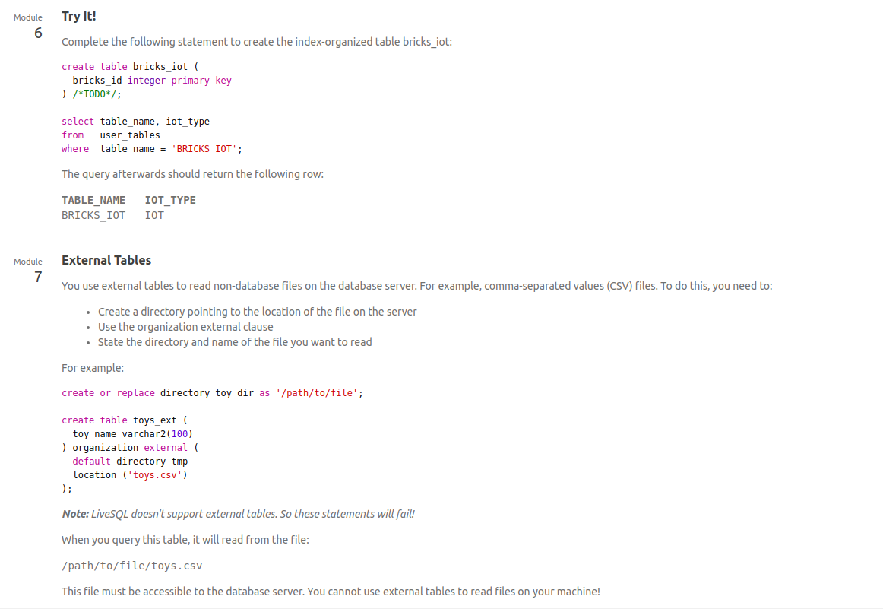

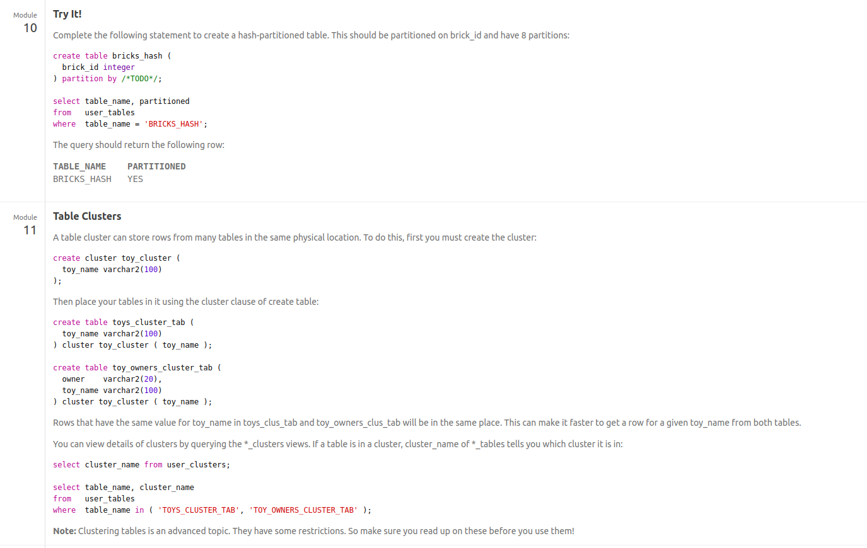

1. What is the difference between VARCHAR and NULL

Ans) VARCHAR is reserved by Oracle to support distinction between NULL and empty string in future, as ANSI standard prescribes.VARCHAR2 does not distinguish between a NULL and empty string, and never will.